Mechanics
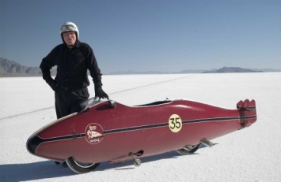
Achievement Standard: Science 1.1 Assessment: External Credits: 4
- Draw and interpret distance-time graphs
- Calculate average speed using v = Δd/Δt
- Determine speed from a distance-time graph
- Draw and interpret speed-time graphs
- Calculate average acceleration using a = Δv/Δt
- Determine acceleration from a distance-time graph
- Name some common forces
- Apply Newton’s First Law of Motion: when the forces on an object are balanced, the object will remain in the same state of motion
- Draw free-body force diagrams
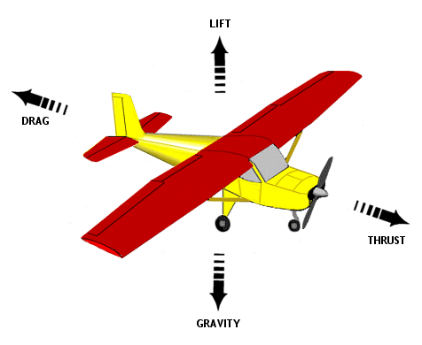
- Apply Newton’s Second Law of Motion: when the forces on an object are unbalanced the object will accelerate
- Calculate force and acceleration using F = ma
- Distinguish between mass and weight
- Calculate weight force using F_{W} = mg
- Define pressure as the force applied per unit area
- Calculate pressure using P = F/A
- Calculate kinetic energy using E_{K} = ½ mv²
- Calculate gravitational potential energy using E_{P} = mgh
- Define work as the transfer of mechanical energy
- Calculate working using W = Fd
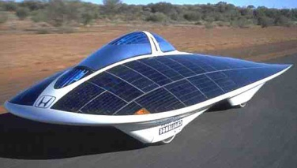
- Explain that when an object is in free fall, gravitational potential energy is converted to kinetic energy
- Define power as the rate of energy transfer
- Calculate power using P = W/t

Macleod
Mechanics
Achievement Standard: Science 1.1 Assessment: External Credits: 4
- Draw and interpret distance-time graphs
- Calculate average speed using v = Δd/Δt
- Determine speed from a distance-time graph
- Draw and interpret speed-time graphs
- Calculate average acceleration using a = Δv/Δt
- Determine acceleration from a distance-time graph
- Name some common forces
- Apply Newton’s First Law of Motion: when the forces on an object are balanced, the object will remain in the same state of motion
- Draw free-body force diagrams
- Apply Newton’s Second Law of Motion: when the forces on an object are unbalanced the object will accelerate
- Calculate force and acceleration using F = ma
- Distinguish between mass and weight
- Calculate weight force using F_{W} = mg
- Define pressure as the force applied per unit area
- Calculate pressure using P = F/A
- Calculate kinetic energy using E_{K} = ½ mv²
- Calculate gravitational potential energy using E_{P} = mgh
- Define work as the transfer of mechanical energy
- Calculate working using W = Fd
- Explain that when an object is in free fall, gravitational potential energy is converted to kinetic energy
- Define power as the rate of energy transfer
- Calculate power using P = W/t

Macleod

