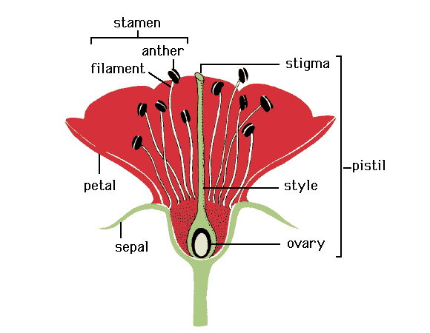
http://faculty.abe.ufl.edu/~chyn/age2062/lect/lect_15/22_62.GIF accessed 20/10/01

http://faculty.abe.ufl.edu/~chyn/age2062/lect/lect_15/22_62.GIF accessed 20/10/01

