Electromagnetism
Achievement Standard: Science 1.2 Assessment: Internal Credits: 4
Static Electricity
- State that an object can have a positive, negative or neutral charge
- State that opposite charges attract, like charges repel
- Explain the difference between conductors and insulators
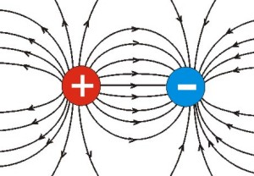
- Draw the distribution of charges on an object
- Describe what happens when an object is ‘earthed’
- Describe how a charged object discharges in air
- Describe how an object can be charged by friction
- Describe how an object can be charged by contact

Current Electricity
- Define voltage, current and resistance
- Draw circuit diagrams using the correct symbols
- Calculate voltage across a resistor using Ohm’s Law V = IR
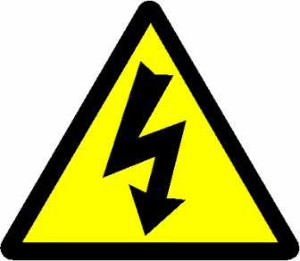
- Explain the difference between series circuits and parallel circuits
- Calculate the total resistance of a series circuit
- Calculate the total resistance of a parallel circuit
- Calculate electrical power using P = VI
- Discuss electrical safety features

Magnetism
- Recall that magnetic field lines go from north to south
- Draw magnetic field lines around a bar magnet, current-carrying wire, and a solenoid
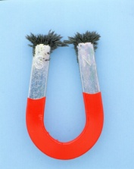
- Use the right-hand-grip rule to determine the direction the magnetic field around a current-carrying wire
- Explain how an electromagnet works
- Explain uses of electromagnets
Electromagnetism
Achievement Standard: Science 1.2 Assessment: Internal Credits: 4
Static Electricity
- State that an object can have a positive, negative or neutral charge
- State that opposite charges attract, like charges repel
- Explain the difference between conductors and insulators
- Draw the distribution of charges on an object
- Describe what happens when an object is ‘earthed’
- Describe how a charged object discharges in air
- Describe how an object can be charged by friction
- Describe how an object can be charged by contact

Current Electricity
- Define voltage, current and resistance
- Draw circuit diagrams using the correct symbols
- Calculate voltage across a resistor using Ohm’s Law V = IR
- Explain the difference between series circuits and parallel circuits
- Calculate the total resistance of a series circuit
- Calculate the total resistance of a parallel circuit
- Calculate electrical power using P = VI
- Discuss electrical safety features

Magnetism
- Recall that magnetic field lines go from north to south
- Draw magnetic field lines around a bar magnet, current-carrying wire, and a solenoid
- Use the right-hand-grip rule to determine the direction the magnetic field around a current-carrying wire
- Explain how an electromagnet works
- Explain uses of electromagnets

